**VEHICLE NUMBER DETECTION USING MATLAB**

A Mini project report submitted in partial fulfillment of the requirements

for the award of the degree of

**BACHELOR OF TECHNOLOGY IN**

**ELECTRICAL AND ELECTRONICS ENGINEERING**

By

**T.DEEKSHITH(18245A0222)**

**P.PAVAN KALYAN(17241A02A3)**

**Y.UMAKANTH(18245A0224)**

**CH.SRI HARSHA(17241A02B7)**

Under the guidance of

**P.SIRISHA**

**Assistant Professor**



***DEPARTMENT OF ELECTRICAL AND ELECTRONICS ENGINEERING***

# GOKARAJU RANGARAJU

**INSTITUTE OF ENGINEERING & TECHNOLOGY**

(Autonomous) Bachupally, Hyderabad-500090

TELANGANA 2019

**GOKARAJU RANGARAJU**

# INSTITUTE OF ENGINEERING & TECHNOLOGY

(Autonomous)

Bachupally,Hyderabad,Telangana.

***DEPARTMENT OF ELECTRICAL & ELECTRONICS ENGINEERING***



**CERTIFICATE**

Certified that this is a Bonafide record of the dissertation work entitled, **“VEHICLE NUMBER DETECTION USING MATLAB”** done by T.DEEKSHITH, P.PAVAN KALYAN, Y.UMAKANTH , CH.SRI HARSHA

under the guidance of **P.SIRISHA** submitted to the faculty of

Electrical and Electronics Engineering, in partial fulfillment of requirements for Industrial Oriented Mini Project Laboratory.

**Signature of Guide:**

P.Sirisha

Assistant Professor Department of EEE GRIET

**Signature of the Coordinator**

**Signature of Head of Department:**

Dr. J Sridevi Professor Department of EEE GRIET

**Signature of the External**

**ACKNOWLEDGEMENT**

We would like to express our deep sense of gratitude to our project Guide **Dr.S.V.JayaRam Kumar,** Professor, EEE department who was very cooperative and whose guidance was invaluable and inspiring throughout the work.

We are thankful to **Dr. Jandhyala N Murthy,** Director, GRIET and **Dr.J. Praveen**, Principal, GRIET for permitting us to use equipment and other facilities that have enabled us to successfully complete this project.

We extremely thankful to **Dr. J Sridevi**, Head of the EEE Department, GRIET for her valuable suggestion extending during the course of the work.

We would also thank **Mr.M.Prashanth Kumar**, Assistant Professor, EEE, for support and suggestion for enriching our spirits in completing this project report.

We are very much thankful to our family and friends who have extended their cooperation to finish this report.

**T.Deekshith(18245A0222)**

**P.Pavan Kalyan(17241A02A3)**

**Y.Umakanth (18245A0224)**

**CH.Sri Harsha(17241A02B7)**

**INDEX**

|  |  |
| --- | --- |
| **Topic** | **Page no** |
| Abstract | i |
| Contents | ii |
| List of Figures | iv |
| List of Tables | v |

**ABSTRACT**

Vehicle number detection is the most energizing and testing project theme from recent years. Number plates are of various shape, measure and furthermore have distinctive shading in various nations. In India the most well-known vehicle number plate utilized have yellow or white as foundation and dark as closer view shading. Right now proposed a framework for confinement of number plate for vehicles in India and fragmented the numbers as to recognize each number independently. The most part center around two stages; one is to capture pictures using pi camera by interfacing raspberry pi with matlab and second is to section all the number and letters to recognize each number independently. The project is created utilizing MATLAB.

This project work is actualized on the passage for security control of a profoundly confined region like military zones or region around top government workplaces for example parliament, Supreme Court and so forth., The created framework identifies the vehicles number to rebuff the individuals who doesn't keep the traffic manages by giving challan to their home.

**CONTENTS**

## CHAPTER-1

Introduction 1

1.1 project overview 1

1.2 Organisation chart 2

CHAPTER-2

* 1. Block Diagram 3
  2. Components list 3
  3. **Components Description**
     1. MATLAB SOFTWARE 4
     2. Laptop 5
     3. Number Plates 6
     4. Pi Camera 7
     5. Raspberry pi model 3b+ 9
     6. Google Drive 12

CHAPTER-3

* 1. Circuit Diagram 13
  2. Operation 13

CHAPTER- 4

* 1. Program Code 18
  2. Procedure 21
  3. Hardware Result 22

Chapter 5

* 1. Conclusion 26
  2. Future Scope 26

Reference

**LIST OF FIGURES**

FIG 2.1(A) Block Diagram using mobile phone

FIG 2.1(B) Block Diagram using raspberry pi

FIG 2.3.1(A) MATLAB SOFTWARE

FIG 2.3.2(A) Laptop using matlab software version

FIG 2.3.3(A) Number Plate

FIG 2.3.3(B) Number plates types

FIG 2.3.4(A) Pi Camera

FIG 2.3.5(A&B) Raspberry pi Model 3B+

FIG 2.3.6(A) Google Drive

FIG 3.1(A) Circuit Diagram

FIG 4.3(A) Number Plate image using mobile phone

FIg 4.3(B) Number Plate image in matlab using NPR technique

FIG 4.3(C) Output in text file after character segementation

FIG 4.3(D) Final output

FIG 4.3(E) Interfacing of pi camera and raspberry pi with matlab

FIG 4.3(F) Image capturing of number plates using pi camera

FIG 4.3(G) Obtained output after processing of matlab

FIG 4.3(H) Final output of toll gatec

**LIST OF TABLES**

TABLE 2.3.4(A) Pin Description of Pi Camera

## CHAPTER 1

## INTRODUCTION

It is seen that the number plates of vehicles are fit as a fiddle

and estimate and have distinctive shading in different nations. In this way, it is a

difficult errand. It is hard to recognize the boundary of the Number plate from the

vehicle pictures in outside scene because of shade of characters of the number plate

and Background of the Number plate the inclinations of the first picture is received

to identify applicant number plate districts. There are likewise calculations that depend on a blend of morphological activity, division and watchful edge finder. Tag area calculation comprise of steps like as Edge Detection, Morphological activity like expansion and disintegration, Smoothing, division of characters and acknowledgment of plate characters. Afterward, we are going to discuss each progression clearly.

This project requires interfacing of raspberry pi with matlab in order

to capture images from pi camera which in turn connected to raspbeery pi. this requirement can be acheived by using hardware support packages which needs to be installed in matlab.

## Project overview

n embedded system is a combination of software and hardware to perform a dedicated task. Some of the main devices used in embedded products are Microprocessors and Micro controllers.

Microprocessors are commonly referred to as general purpose processors as they simply accept the inputs, process it and give the output. In contrast, a micro controller not only accepts the data as inputs but also manipulates it, interfaces the data with various devices, controls the data and thus finally gives the result.

# Organisation chart

The thesis explains the implementation of “ Vehicle Number Detection Using MATLB” . The organization of the thesis is explained here with:

Chapter 1 Presents introduction to the overall thesis and the overview of the project.

Chapter 2 Presents the components description. It deals with the block diagram of the project and explains the purpose of each block.

Chapter 3 presents the Circuit Diagram and operation .

Chapter 4 Presents the software of the project.

Chapter 5 Presents the conclusion and future scope of the project.

## CHAPTER 2

**2.1 Block Diagram**

* Block diagram for images captured using a mobile camera:

Images uploaded to Google drive

**Image captured from mobile camera**

NUMBER PLATE

LAPTOP

**FIG 2.1(A)**

* Block diagram for images captured using a pi camera:

NUMBER PLATE

**Image captured from pi camera Connected to raspberry pi**

Interfacing and connecting to a common Wi-Fi network

LAPTOP

# FIG2.1(B)

# 2.2 COMPONENTS LIST

1. Matlab software
2. Laptop
3. Number plates
4. Pie camera
5. Raspberry pie MODEL 3B+
6. Mobile phone

7.Google drive

# 2.3 Components Description

## MATLAB SOFTWARE:

In 1970, a mathematician and computer programmer **Cleve Moller** invented MATLAB. **MATLAB** is called as "matrix laboratory”. MATLAB perform following operations like array indexing, creating variables, arithmetic operations and data analytics etc.,

**Applications of MATLAB**

1. Artificial intelligence
2. Simulating different electrical networks
3. Robotics
4. Machine Learning
5. Data analytics
6. Wireless communication
7. Image processing

In this project we are, using MATLAB R2018b version.

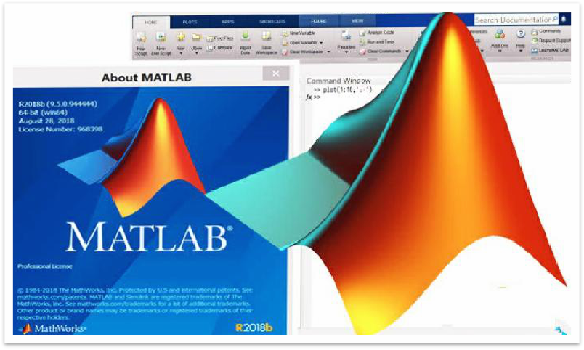 **FIG 2.3.1(A)**

**LAPTOP**

In 1981 laptop was invented by Adam Osborne. The laptop is termed as ''Osborne”. A laptop is a personal computer. This is also named as Notebook. This is very small, portable, easy to fold etc.,

Features of a laptop

1. RAM with more than 4gb
2. Good speed Processor(intel processor like core i3,corei5,core i7)
3. Screen Resolution (1920*108 Dedicated Graphics and small Screen size
4. Hard disk drive
5. USB Type C port
6. Longer battery life
7. Touch
8. Infrared camera
9. Light in weight
10. Good power consumption etc.,
11. 2 in 1 PC’s

Nowadays without laptop or computer, we can’t do anything. The following areas in which laptops are used:

* Banking
* Education
* Medical
* Scientific and Research etc.,

In this project, we are using a Laptop with MATLAB software.

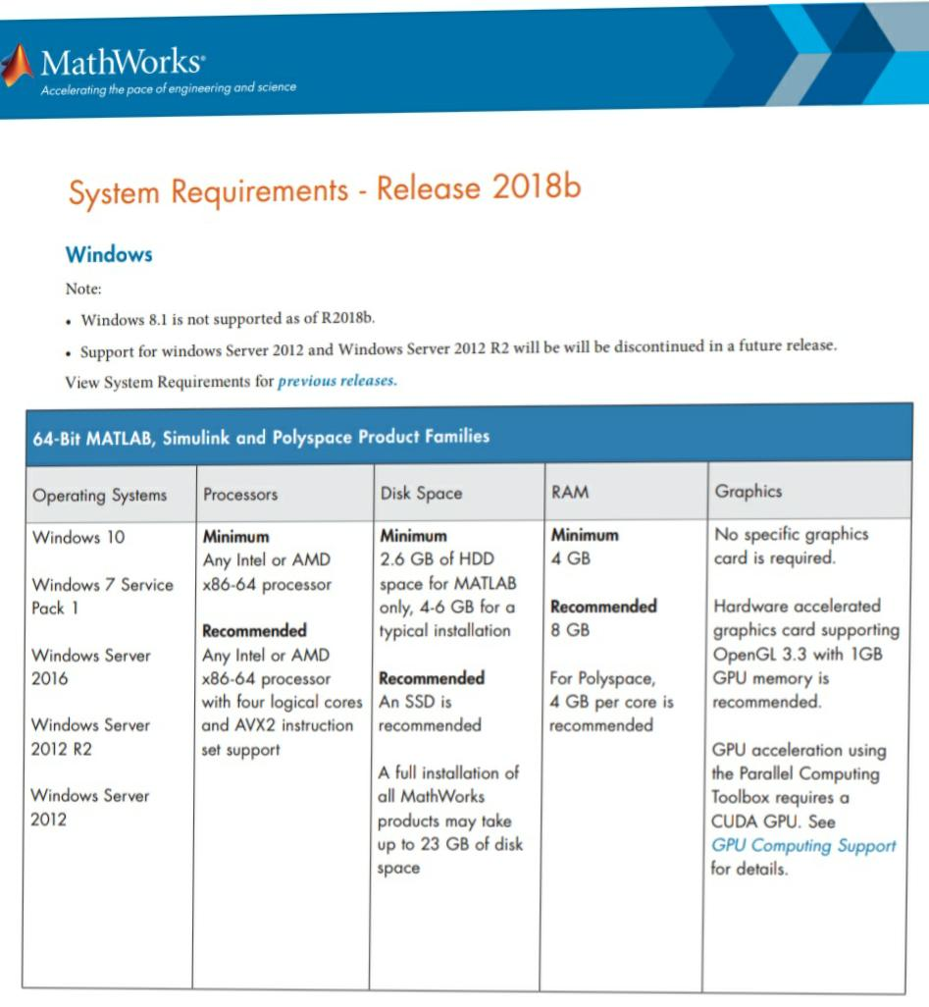 **FIG 2.3.2(A)**

**NUMBER PLATES**

* + Number plate contains the number of the vehicle.It is different for several countries. In India we are utilizing three shades for number plates, the shades are yellow, white and black. Yellow and white colours are used for the background of the number plate, black is employed to indicate the numbers on the plate. According to the Government of Road Transport Authority. After completing Registration, The owner of the vehicle given by a number. This number is positioned on both the front and rare sides of the vehicle using plates

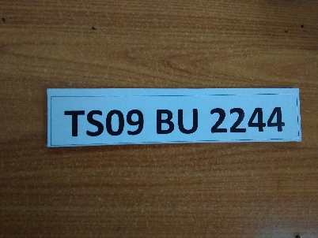 **FIG 2.3.3(A)**

The number on the plate furthermore demonstrates that the vehicle belongs to which state. For example, if the Telangana number is like(TS 15 EU 0830), Andrapradesh number is like (AP 23 MN 5672) and soon.

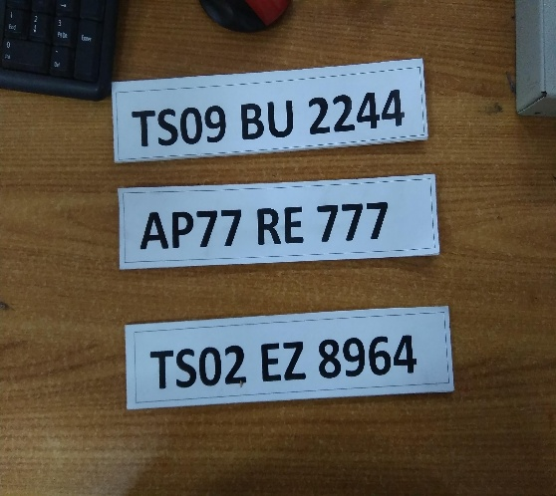 **FIG 2.3.3(B)**

In our project we are made some different number plates like the working number plates, Fake number plates, Different state number plates etc.,

**PI CAMERA**

The **Pi camera**  is a small and light weight camera that aids Raspberry Pi. It interfaces with Pi using the MIPI camera serial interface protocol. It is generally used in machine learning, image processing or in surveillance projects. It is normally employed in drones since the weight of camera is very less. In associate With these Pi can also use USB webcams that can also operate with computer.

### **Pi Cam Features**

### Applicable Raspberry Pi Model A and Model B

* 5MP colour camera for [Raspberry Pi](https://components101.com/microcontrollers/raspberry-pi-3-pinout-features-datasheet)
* MIPI serial interface
* 2592 * 1944 Resolution
* Omni vision 5647 Camera
* Supports: 1080p, 720p and 480p
* Portable and Lightweight

**Pin Description**

|  |  |  |
| --- | --- | --- |
| **Pin Number** | **Pin Name** | **Description** |
| 2,3 | CAM1_DP0,  CAM1_DN0 | MIPI Data Negative and  MIPI Data Positive for data lane 0 |
| 1,4,7,10 | Ground | System Ground |
| 5,6 | CAM1_DP1,  CAM1_DN1 | MIPI Data Negative and MIPI Data Positive for data lane 1 |
| 8,9 | CAM1_CP,  CAM1_CN | These pins give clock pulses for MIPI data lanes |
| 11 | CAM_GPIO | GPIO pin utilized optionally |
| 12 | CAM_CLK | Elective clock pin |
| 13,14 | SCL0, SDA0 | Employed for I2C communication |
| 15 | +3.3V | Power supply pin |

### **TABLE 2.3.4(A)**

### **How to connect Camera with Pi**

The **Pi camera** when acquired comes with a cable, this cable has to be attached to the **CSI**(Camera Serial Interface) **port of the Pi**. This port can be originate near the HDMI port just attach the cable to it as shown below.

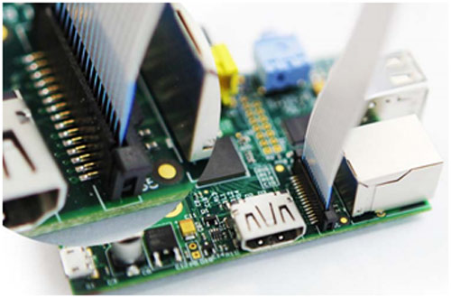

**FIG 2.3.4(A)**

After interfacing the pi camera, we have to set up the Pi to enable Camera. Using the command “**sudo raspi-config**” to open the arrangement window. In interfacing options enable camera. Ultimately reboot the Pi and your camera is available to use. Then, you can put together the Pi to capture photos or record videos using easy python scripts.

### **Applications**

* Time-lapse video recording
* Surveillance projects
* Machine learning
* Robotics
* Image processing
  + 1. **RASPBERRY Pi MODEL 3B+**

The raspberry pi 3 Model B+ is the enormous development in the raspberry 3 range, showing off a 6 bit quad core processor operating at 1.4GHZ and dual band 2.4GHZ and 5GHZ wireless LAN, 4.2BLE faster Ethernet , Bluetooth and PoE capabilities via a distinct PoE HAT.

## 

**FIG 2.3.5(A)**

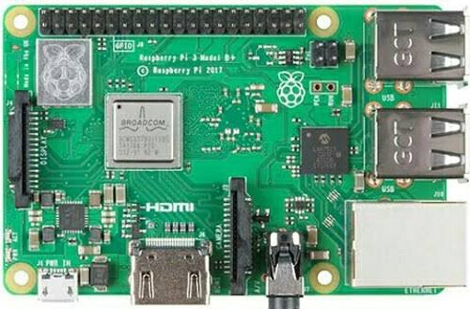

**FIG 2.3.5(B)**

The dual band wire less LAN appears with modular subordination certification, enabling the board to be manufactured into end products with considerably diminished wireless LAN compliance testing, enhance both cost and time to demand.

The raspberry pi 3 Model B+ has possessing the similar mechanical impression as both raspberry pi 2 model B and raspberry pi 3 model B.

**Specifications**

The Raspberry Pi 3 Model B+ is the ultimate revision in the Raspberry Pi 3 size.

* 1GB LPDDR2 SDRAM
* Bluetooth 4.2, BLE, 5GHz and 2.5GHz IEEE 802.11.b/g/n/ac wireless LAN,
* 40-pin GPIO header
* Power-over-Ethernet (PoE) support (requires PoE HAT)
* HDMI
* Cortex-A53 (ARMv8) 64-bit SoC @ 1.4GHz, Broadcom BCM2837B0
* CSI camera port for connecting a Pi camera
* Gigabit Ethernet over USB 2.0 (maximum throughput 300 Mbps)
* DSI display port for connecting a touchscreen display
* composite video port and 4-pole stereo output
* Micro SD port for storing data and loading operating system
* 5V/2.5A DC power supply input
* 4 USB 2.0 ports

**WARNINGS**

* This product only be engaged to an external power supply rated at 5V dc, and an extreme current of 500-700mA for model A and 700-1200mA for model B. Any outside power supply tried with the Raspberry-Pi comply with related limitations and standards practical in the region of intended use.
* This product should not be totally enclosed as this may bring in certain components very hot.
* This product should be operated in a well open atmosphere and should not be enclosed.
* This product should be installed on a safe, horizontal, non-conductive surface in use and should not be reached by conductive elements.
* The connection of unadevices to the GPIO connector may affect compliance or result in damage to the unit and invalidate the warranty.

**INSTRUCTIONS FOR SAFE USE**

To avoid malfunctioning or destruction of your Raspberry Pi please examine the following:

* Do not place it no water, moisture or place on a conductive ground while in working
* Do not expose it to heat; the Raspberry Pi is designed for responsible operation at normal room temperatures.
* Take care while dealing with to avoid mechanical or electrical defect to the PCB and connectors.
* Prevent handling the Raspberry Pi while it is connected. Only hold by the corners to minimise the threat of electrostatic discharge damage.
* Each peripherals used with the Raspberry Pi should acknowledge with related standards for the region of use and be captioned accordingly to assure that safety and performance provisions are met. These articles not limited to monitors, keyboards and mice used in conjunction with the Raspberry Pi.
* The Raspberry Pi is not manufactured to be powered from a USB port on other related equipment, if this is undertaken may malfunction.

**Mobile phone**

* This project using mobile phone to capture the image for image processing.

A smart phone having minimum 5mp camera is required for image capturing.

**2.3.6 GOOGLE DRIVE**

**Google Drive** refers to a file storage and synchronization service manufactured by Google. Commenced on April 24, 2012, Google Drive enables customers to stock files on their servers, synchronize files in devices, and send files.In extension to a website, Google Drive gives applications with abilities for macOS Windows computers ,and Android and iOS smartphones and tablets. Google Drive comprises  Google Docs, Google Sheets, and Google Slides, which are a components of an office suite that allows collective editing of spreadsheets, documents, drawings, forms, presentations and more. Files developed and edited with the office suite are stored in Google Drive.



**FIG 2.3.6**

## CHAPTER 3

**3.1 CIRCUIT DIAGRAM**

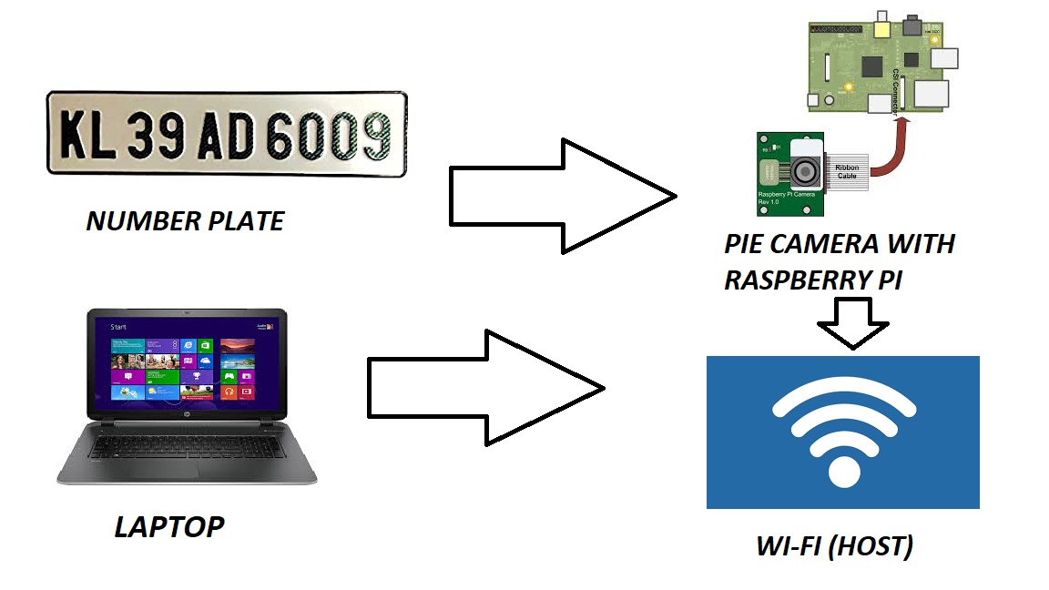

**FIG 3.1(A)**

## 3.2 OPERATION

* **Capturing vehicle images for processing in MATLAB to identify vehicle number :**

For capturing images this project using two different techniques

1. Capturing images by using pi camera which is connected to raspberry pi model 3b+. The raspberry pi needs to interface with MATLAB for the purpose of transferring an image to MATLAB for further processing. Interfacing and communication between raspberry pi with MATLAB explained in detail in procedure for setup.
2. Capturing images by using a mobile camera and upload the image to Google drive sync folder which is a common sync folder for both laptop and mobile phone. The uploaded images automatically download in laptop by using the internet due to syncing between mobile and laptop.

* **Processing the captured images in MATLAB.**

For processing the images to get the vehicle number we need to run the MATLAB code which is given in the program code. The program code perform following operation.

**Number Plate Recognition System (NPR) :**

This process is for identifying the vehicle number from images. This process has Several Sections as given I this diagram.

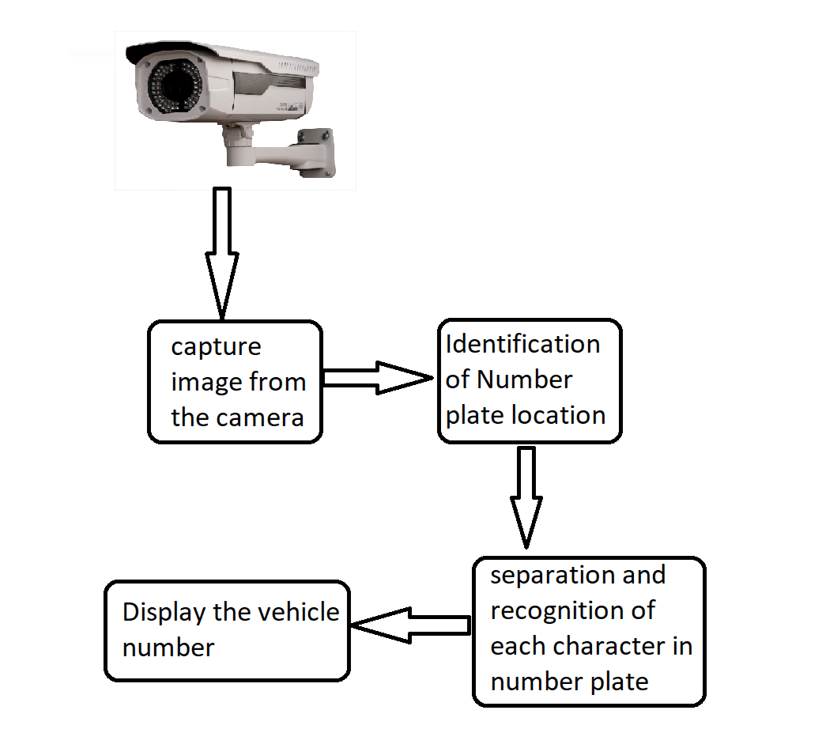

**FIG 3.2(A)**

**Extraction of number plate location :**

The captured images are given as input to the code. RGB to grayscale conversion is performed, for number plate extraction, and to increase the speed of processing. Colour image captured by a camera is converted to grayscale image using I gray =0.114*r+0.587*g+0.299*b………(1) Here mathematical calculations are used to detect the region and to calculate the threshold value sobel operator is used. We get a dilated image after this process. Then imfill command is used to fill the gaps, so that, we get a clean binary image. Bounding box technique is used to identify the number plate which is in rectangle shape with a desired area in a given image.

The following section of the code performs the number plate extraction.

imggray = rgb2gray(img); % grayscale conversion

imbinary = imbinarize(imggray);

img = edge(imggray, 'sobel'); %edge detection

img = imdilate(img, strel('diamond', 2)); %image filtering

img = imfill(img, 'holes');

im = imerode(im, strel('diamond', 10));

%finding the location of number plate

Ipropertys=regionprops(img,'BoundingBox','Area', 'Image');

Area = Ipropertys.Area;

count = numel(Ipropertys);

Maxa= Area;

BoundingBox = Ipropertys.BoundingBox; %for comparing and finding the area

for i=1:count

   if Maxa<Ipropertys(i).Area

       Maxa=Ipropertys(i).Area;

       BoundingBox=Ipropertys(i).BoundingBox;

   end

end

**Character segmentation :**

Segmentation is an important process in the number plate recognition because all next steps depend on this. If segmentation failed, a character can be improperly divided into two parts or two characters. To solve this problem, we are using to use bounding box technique. The bounding box is used to know the properties of the image. After creating a bounding box each letter and numbers on the number plate, each letter & number separately comes out for recognition of number plate. And each letter is identified by comparing with created templates in the code. All the letters will be appended one by one in the character array. The following segment of code will perform character segmentation and give vehicle number.

%read letter

Iprops=regionprops(im,'BoundingBox','Area', 'Image');

count = numel(Iprops);

noPlate=[];

pevplate=[];

% Initializing the variable of number plate string.

for i=1:count

   ow = length(Iprops(i).Image(1,:));

   oh = length(Iprops(i).Image(:,1));

   if ow<(h/2) && oh>(h/3)

       letter=readLetter(Iprops(i).Image); % Reading the letter corresponding the binary image 'N'.

       figure; imshow(Iprops(i).Image);

       noPlate=[noPlate letter]; % Appending every subsequent character in noPlate variable.

   end

end

if(pevplate!=noPlate)

b=noPlate;

T = readtable('data.xlsx','ReadRowNames',true);

a=T(b,1);

x=string(table2cell(T(b,3));

if x=="paid"

D="open"

else

d="hello mr.";

e=" your vehicle no ";

f=" needs to pay toll fee in order to pass through toll gate in counter or though this link https://v1.hdfcbank.com/htdocs/common/fastag/index.html ";

c=string(table2cell(T(b,2)));

g=d+c+e+(string(b))+f;

setpref('Internet','SMTP_Server','smtp.gmail.com');

setpref('Internet','E_mail','vehiclenumber12@gmail.com');

setpref('Internet','SMTP_Username','vehiclenumber12@gmail.com');

setpref('Internet','SMTP_Password','VehiclenumberEEE');

props = java.lang.System.getProperties;

props.setProperty('mail.smtp.auth','true');

props.setProperty('mail.smtp.socketFactory.class', 'javax.net.ssl.SSLSocketFactory');

props.setProperty('mail.smtp.socketFactory.port','465');

sendmail(string(table2cell(a)),"toll fee payment",g);

end

pevplate=noPlate;

end

end

* **Data handling with MATLAB :**

After obtaining the vehicle number from the NPR system, that vehicle number needs to be compared with the database in excel sheet to know necessary details. this can be performed by the MATLAB with file handling techniques used in code. Excel data provided to MATLAB will be converted into a table, And vehicle number obtained will be compared with respective column data to find details. Corresponding details will be taken by the code for further processing. The following section of the code performs data handling and give the information related to the vehicle owner.

b=noPlate;

T = readtable('data.xlsx','ReadRowNames',true); % read the exel data into MATLAB.

a=T(b,1); % comparing the vehicle numbers

x=string(table2cell(T(b,3)); %reading corresponding information

## 

* **Sending mail to respective vehicle owner :**

In our project we send mail to respective owner in two applications: 1. images captured using the phone camera.

2. Images captured using pi camera.

1.images captured using phone camera: this application is implemented for traffic police officers to inform the vehicle owner by sending mail that challan has paid for violating the traffic rules.

2.images captured using pi camera: this application is implemented for informing the vehicle owner to pay a toll fee to pass toll gate by sending an email.

The following section of the code performs sending an email to the vehicle owner.

g=d+c+e+(string(b))+f; %creating a mail to send

%properties are adjusted for sending mail

setpref('Internet','SMTP_Server','smtp.gmail.com');

setpref('Internet','E_mail','vehiclenumber12@gmail.com');

setpref('Internet','SMTP_Username','vehiclenumber12@gmail.com');

setpref('Internet','SMTP_Password','VehiclenumberEEE');

props = java.lang.System.getProperties;

props.setProperty('mail.smtp.auth','true');

props.setProperty('mail.smtp.socketFactory.class', 'javax.net.ssl.SSLSocketFactory');

props.setProperty('mail.smtp.socketFactory.port','465');

sendmail(string(table2cell(a)),"toll fee payment",g); %send mail

## CHAPTER -4

## 4.1 PROGRAM CODE

This project has two different codes one for capturing images with a mobile camera and the other one is for capturing images with pi camera.

**Program code for capturing images using a mobile camera:**

location = 'folder location';       %  folder in which your images exists  
ds = imageDatastore(location);         %  Creates a datastore for all images in your folder  
while hasdata(ds)  
    im = read(ds) ;% read image from datastore  
  figure, imshow(im); % creates a new window for each image  
im = imresize(im, [480 NaN]);  
imgray = rgb2gray(im);  
imbin = imbinarize(imgray);  
im = edge(imgray, 'sobel');  
im = imdilate(im, strel('diamond', 2));  
im = imfill(im, 'holes');  
im = imerode(im, strel('diamond', 10));  
Iprops=regionprops(im,'BoundingBox','Area', 'Image');  
area = Iprops.Area;  
count = numel(Iprops);  
maxa= area;  
boundingBox = Iprops.BoundingBox;  
for i=1:count  
   if maxa<Iprops(i).Area  
       maxa=Iprops(i).Area;  
       boundingBox=Iprops(i).BoundingBox;  
   end  
end      
  
%all above step are to find location of number plate  
  
im = imcrop(imbin, boundingBox);  
  
%resize number plate to 240 NaN  
im = imresize(im, [240 NaN]);  
  
%clear dust  
im = imopen(im, strel('rectangle', [4 4]));  
  
%remove some object if it width is too long or too small than 500  
im = bwareaopen(~im, 500);  
%%%get width  
 [h, w] = size(im);  
imshow(im);  
  
  
%read letter  
Iprops=regionprops(im,'BoundingBox','Area', 'Image');  
count = numel(Iprops);  
  
noPlate=[]; % Initializing the variable of number plate string.  
  
for i=1:count  
   ow = length(Iprops(i).Image(1,:));  
   oh = length(Iprops(i).Image(:,1));  
   if ow<(h/2) && oh>(h/3)  
       letter=readLetter(Iprops(i).Image); % Reading the letter corresponding the binary image 'N'.  
       figure; imshow(Iprops(i).Image);  
       noPlate=[noPlate letter]; % Appending every subsequent character in noPlate variable.  
   end  
end  
b=noPlate;  
d="hello mr.";  
e=" your vehicle no ";  
f=" punished with challan for breaking traffic rules better to pay thorugh [tsstrc.com](http://tsstrc.com/)";  
T = readtable('data.xlsx','ReadRowNames',true); %read data in excel sheet   
a=T(b,1);  
c=string(table2cell(T(b,2)));  
g=d+c+e+(string(b))+f;  
setpref('Internet','SMTP_Server','[smtp.gmail.com](http://smtp.gmail.com/)');  
setpref('Internet','E_mail','[vehiclenumber12@gmail.com](mailto:vehiclenumber12@gmail.com)');   
setpref('Internet','SMTP_Username','[vehiclenumber12@gmail.com](mailto:vehiclenumber12@gmail.com)');  
setpref('Internet','SMTP_Password','VehiclenumberEEE');  
props = java.lang.System.getProperties;  
props.setProperty('mail.smtp.auth','true');  
props.setProperty('mail.smtp.socketFactory.class', 'javax.net.ssl.SSLSocketFactory');  
props.setProperty('mail.smtp.socketFactory.port','465');  
sendmail(string(table2cell(a)),"traffic challan",g); %send mail  
end

**Program code for capturing images using a pi camera:**

mypi = raspi(ipaddress,username,password)

mycam = cameraboard(mypi,'Resolution','1280x720')

pevplate=[];

while 1

    im= snapshot(mycam)

  figure, imshow(im); % creates a new window for each image

im = imresize(im, [480 NaN]);

imgray = rgb2gray(im);

imbin = imbinarize(imgray);

im = edge(imgray, 'sobel');

im = imdilate(im, strel('diamond', 2));

im = imfill(im, 'holes');

im = imerode(im, strel('diamond', 10));

Iprops=regionprops(im,'BoundingBox','Area', 'Image');

area = Iprops.Area;

count = numel(Iprops);

maxa= area;

boundingBox = Iprops.BoundingBox;

for i=1:count

   if maxa<Iprops(i).Area

       maxa=Iprops(i).Area;

       boundingBox=Iprops(i).BoundingBox;

   end

end

%all above step are to find location of number plate

im = imcrop(imbin, boundingBox);

%resize number plate to 240 NaN

im = imresize(im, [240 NaN]);

%clear dust

im = imopen(im, strel('rectangle', [4 4]));

%remove some object if it width is too long or too small than 500

im = bwareaopen(~im, 500);

%%%get width

 [h, w] = size(im);

imshow(im);

%read letter

Iprops=regionprops(im,'BoundingBox','Area', 'Image');

count = numel(Iprops);

noPlate=[];

% Initializing the variable of number plate string.

for i=1:count

   ow = length(Iprops(i).Image(1,:));

   oh = length(Iprops(i).Image(:,1));

   if ow<(h/2) && oh>(h/3)

       letter=readLetter(Iprops(i).Image); % Reading the letter corresponding the binary image 'N'.

       figure; imshow(Iprops(i).Image);

       noPlate=[noPlate letter]; % Appending every subsequent character in noPlate variable.

   end

end

if(pevplate!=noPlate)

b=noPlate;

T = readtable('data.xlsx','ReadRowNames',true);

a=T(b,1);

x=string(table2cell(T(b,3));

if x=="paid"

D="open"

else

d="hello mr.";

e=" your vehicle no ";

f=" needs to pay toll fee in order to pass through toll gate in counter or though this link https://v1.hdfcbank.com/htdocs/common/fastag/index.html ";

c=string(table2cell(T(b,2)));

g=d+c+e+(string(b))+f;

setpref('Internet','SMTP_Server','smtp.gmail.com');

setpref('Internet','E_mail','vehiclenumber12@gmail.com');

setpref('Internet','SMTP_Username','vehiclenumber12@gmail.com');

setpref('Internet','SMTP_Password','VehiclenumberEEE');

props = java.lang.System.getProperties;

props.setProperty('mail.smtp.auth','true');

props.setProperty('mail.smtp.socketFactory.class', 'javax.net.ssl.SSLSocketFactory');

props.setProperty('mail.smtp.socketFactory.port','465');

sendmail(string(table2cell(a)),"toll fee payment",g);

end

pevplate=noPlate;

end

end

**4.2 Procedure for setup to run the code**

As the project has two applications, each application has a separate procedure for setup and to run the code as follows

* **When a mobile camera is used for capturing the images:**

For transferring the images from the mobile to laptop automatically we are using Google Drive. For this process, it is required to install Google drive in phone and laptop. For syncing the folder in both laptop and mobile it is required to do some settings as given below

Step 1: Download and install Google drive back up and sync in both mobile and laptop

Step 2:sign in with Google Account in both laptop and mobile

Step 3: for syncing folders in the laptop, open google back up and sync do some settings as mentioned in help.

Step 4: Select the same folder on mobile which is the selected in the laptop and upload the images

After syncing folder in the laptop, the location of the folder needs to copied on program code

Next step of the setup is to create an excel sheet data with required information of vehicles

Such as vehicle number, Gmail and name etc., save the file in MATLAB documents folder.

Make sure the internet connectivity and run the program in MATLAB.

* **When a pi camera used for capturing the images:**

Pi camera can be directly connected to raspberry pi in the provided onboard slot. For transferring the images from a raspberry pi to MATLAB requires interfacing the raspberry pi with MATLAB. It can be performed with following steps

Step 1: Install the hardware support package for raspberry pi to MATLAB in ‘add

on’ section in home tab of MATLAB.

Step 2: download the MATLAB supported operating system image file of the raspberry pi in the sequential settings during installing support packages.

Step 3: upload the operating system image file into raspberry pi by setting a common Wi-Fi network in both raspberry pi and laptop. The details of the raspberry pi need to be entered during installing support packages.

Step 4: After installing the operating system image, it’s required to give access to MATLAB in raspberry pi to communicate with wireless networks, permission to access hardware and GPIO pins of raspberry pi.

Step 5: After changing settings, raspberry pi needs to restart.

Step 6: by the following commands, the connectivity of raspberry pi and pi camera with MATLAB can be observed.

mypi = raspi(ipaddress, username, password);

% connecting raspberry pi to MATLAB with common Wi-Fi network

mycam = cameraboard(mypi,'Resolution','1280x720')

% accessing pi camera and setting resolution

Step 7: Finally, prepare an excel sheet with necessary details and save the excel sheet in MATLAB documents folder. Run the code in MATLAB.

## 

## 4.3 Hardware Result

* The output using images from mobile phone camera from NPR technique used in source code in MATLAB from image as in below figure

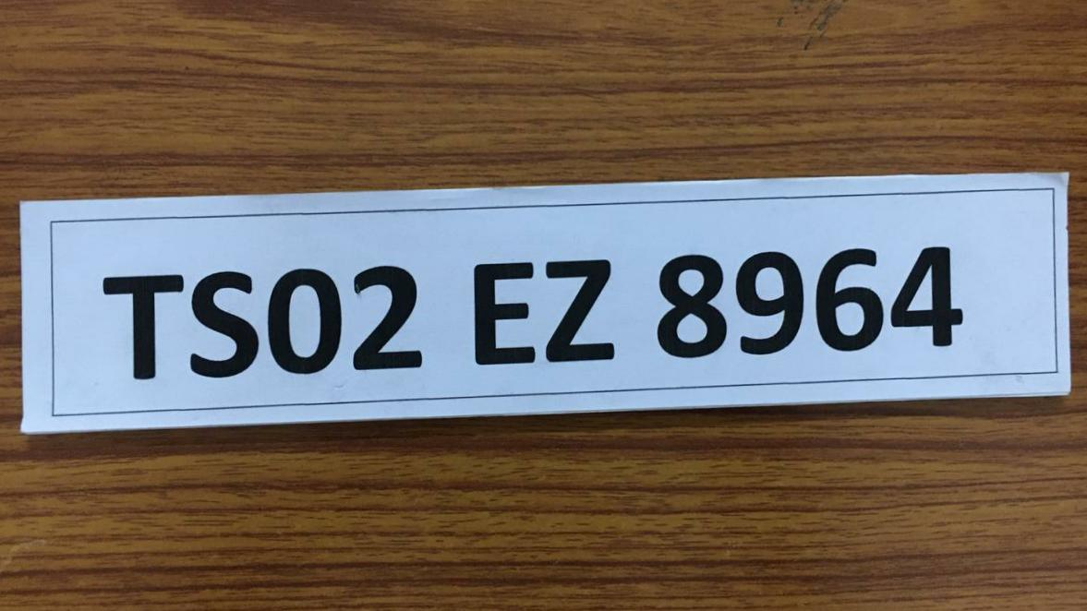**Step-1:-Number plate image captured using mobile phone**.

**FIG 4.3(A)**

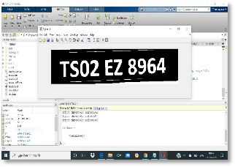**Step-2:-Number plate recongization in MATLAB using NPR technique.**

**FIG 4.3(B)**

**Step-3:output in text file after character segmentation in NPR system**

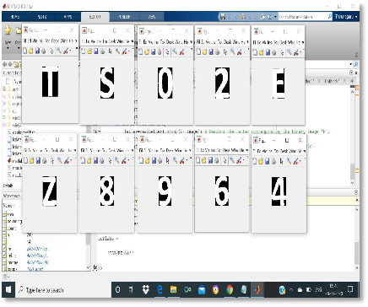

**FIG 4.3(C)**

**Step-4:-Final Output** 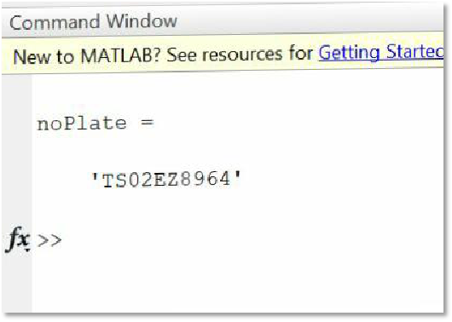

**FIG 4.3(D)**

After obtaining vehicle number mail send to the vehicle owner from program code automatically.

* The output using images from pi camera from NPR technique used in source code in MATLAB from image as in below figure.

After successfully interfacing Raspberry pi and pi camera with MATLAB, following figure shows set up as well as obtained output images.

**Step-1:-Interfacing of Raspberry pi and pi camera using MATLAB software.**

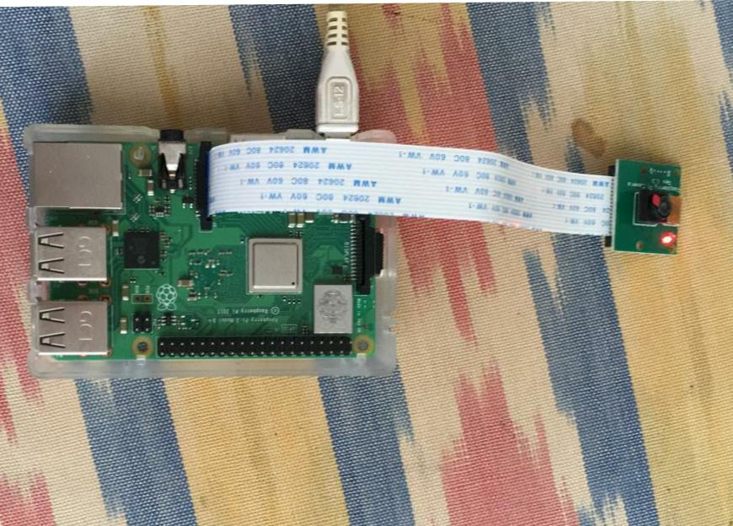

**FIG 4.3(E)**

**Step-2:- Image capturing of NUMBER PLATE using RASPBERRY PI CAMERA .**

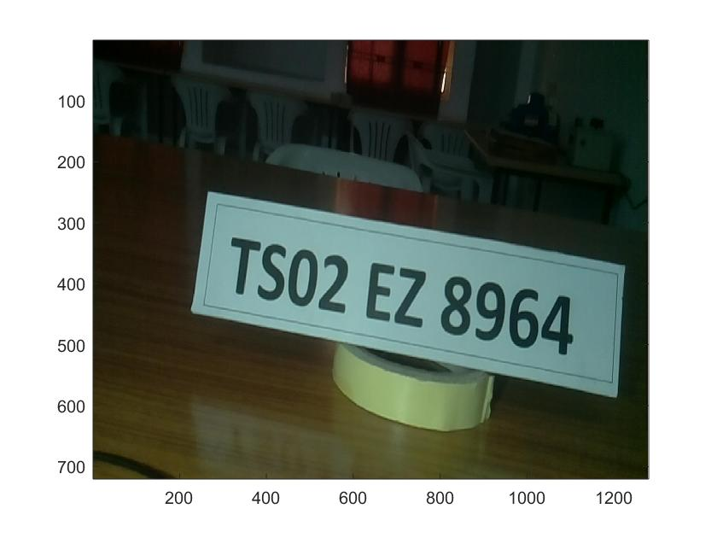**FIG 4.3(F)**

**Step-3:- obtained output after processing in MATLAB.**

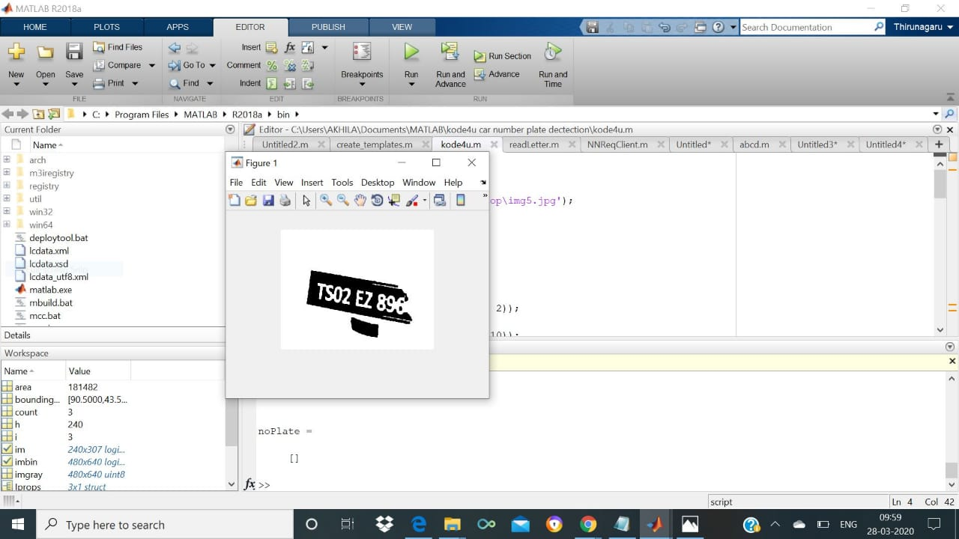

**FIG 4.3(G)**

**Step-4:- Final output for toll gate**

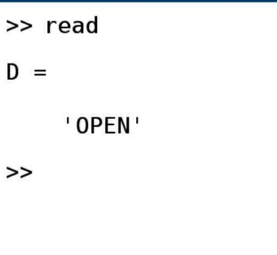 **FIG 4.3(H)**

## CHAPTER 5

## 5.1 CONCLUSION

This project is implemented with all the technically upgraded components. This project used efficient techniques in image processing. This project can be successfully implemented and used in real time applications as mentioned above

## 5.2 FUTURE SCOPE

* This project can be used at the passage for security control of a profoundly confined region like military zones or region around top government workplaces for example parliament, Supreme Court and so forth.,
* This project can be used by traffic police to punish the traffic rule breakers by sending challan to their home automatically.
* This project is useful at the entrances of apartments to open the gates automatically when the owners vehicle at the entrance.
* This project using mail service for informing the vehicle owner. this Project can be extended to send messages with the help of GSM Module

## Reference

The sites which were used while doing this project:

1. [www.wikipedia.com](http://www.wikipedia.com/) 2.[www.circuitdigest.com](http://www.circuitdigest.com/)

3.[www.matlab.com](http://www.circuitdigest.com/)